**Human Growth and Development**

[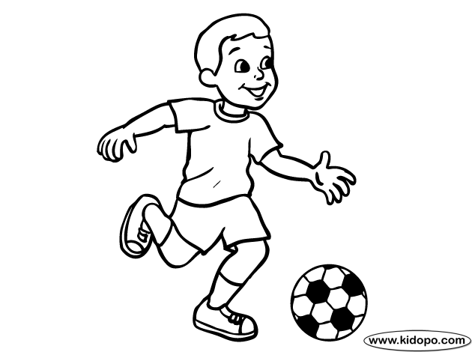](http://www.google.com/url?sa=i&rct=j&q=Boy+playing+soccer&source=images&cd=&cad=rja&uact=8&ved=0CAcQjRw&url=http://printablecolouringpages.co.uk/?s%3Dboy%2Bsoccer%2Bplayer&ei=qCKwVNHQFYjksAShnoIo&bvm=bv.83339334,d.cWc&psig=AFQjCNExBfkQwQ9BVqRAlrICF3ujIyCY-w&ust=1420915721284428)

**Boys Packet**

**Grade 4**

**Central Bucks School District**

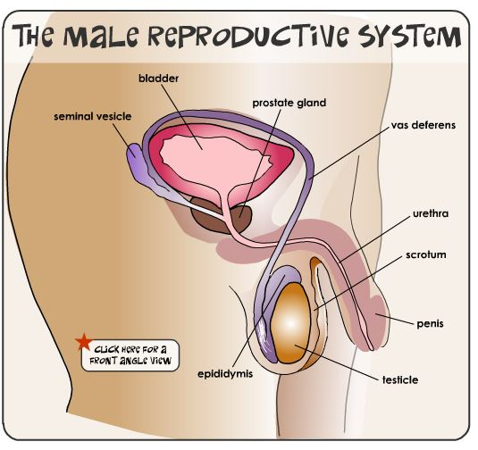

**Keeping clean.**

As you grow up, you will begin to sweat more-especially under your arms-and your sweat can smell bad.

To keep your body clean:

1. 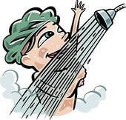[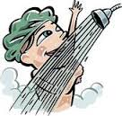](http://www.google.com/url?sa=i&rct=j&q=showering+clipart&source=images&cd=&cad=rja&uact=8&ved=0CAcQjRw&url=http://www.fotosearch.fr/IMZ203/nri0115/&ei=4SWwVLZ0t8uwBP6HgqAI&bvm=bv.83339334,d.cWc&psig=AFQjCNEO6W3mvCbIBvqiitKocTjaKUQ3Xw&ust=1420916540544342)

Take a bath or shower every day-especially after you exercise. Make sure to use soap and rinse completely.



After every bath or shower, use an antiperspirant or deodorant under your arms. Antiperspirants and deodorants come in sprays and solids. Ask an adult to show you how to use yours.

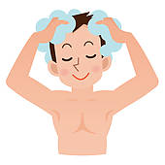

Shampoo your hair often.

Always be sure to rinse out all of the shampoo.

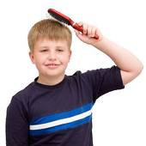

Brush your hair every day to keep it neat.

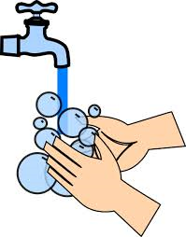

Wash your hands often with soap and water to help stop germs from spreading. Always wash your hands before you eat, after you use the bathroom and after you cough or sneeze.

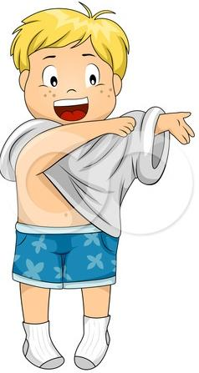

Put on clean clothes, including clean socks and underwear, every day.

**Grade 4**

**Glossary of Terms**

**Males**

**Adolescence:** The period of life during which a person grows from child to adult; from about ages 10 to 21

**Bladder:** A small, elastic sac in the body that stores urine.

**Ejaculation:** The discharge of semen from the penis

**Epididymis:** Ducts that carry sperm from the testes to the vas deferens

**Erection:** Hardening of the penis.

**Genitals:** External sex organs

**Hormone:** A substance that controls the activity of another part of the body.

**Nocturnal Emission:** Also called wet dreams; the occasional, involuntary discharge at night of unneeded semen.

**Penis:** Male sex organ which discharges urine and semen.

**Pituitary Gland:** Small oval gland at the base of the brain; puts out hormones that influence growth and most of the basic functions of the body.

**Prostate Gland:** A gland in males that produces a fluid that liquefies semen.

**Puberty:** Beginning of physical maturation in a boy or girl.

**Scrotum:** External pouch of skin that contains the testicle and is located behind the penis.

**Semen:** Whitish fluid produced in the testicles; this fluid carries the sperm cells.

**Seminal Vesicle:** A sac-like structure in the male that produces a thick fluid that is part of the semen.

**Sperm:** Male reproductive cell.

**Testes or Testicles:** One of the two male sex organs that are contained in the scrotum; after puberty they produce mature sperm cells.

**Testosterone:** A hormone that promotes the development of puberty in a boy.

**Urethra:** The canal that carries urine from the body. Seminal fluid can also pass through this canal.

**Vas Deferens:** One of the small tubes through which sperm pass from the testes to the urethra

Name: ________________ Teacher: ______________ Date: _______

**Knowing Yourself Worksheet**

1. Because of the rapid growth that takes place during adolescence, good nutrition is needed. Which of the following meals would be most healthful?
   1. Hamburger, vegetables, bread, fruit, milk
   2. Pizza, French fried potatoes, pickle, coke
   3. Spaghetti, soda, chocolate cake, coffee
2. Why is it necessary for adolescents to bathe more frequently than you did as a child?

________________________________________________________________________________________________________________________________________________________________________________________________________________________

1. How might the use of deodorants help an adolescent?

________________________________________________________________________________________________________________________________________________

1. As an adolescent you must have plenty of sleep because your body is growing and changing rapidly.
   1. How many hours do you usually sleep each night? _____
   2. How many hours of sleep do you need each night in order to wake up alert the next day? __________
2. List three activities which can help you develop your body and strengthen your muscles?
   1. _____________ b. ______________ c.______________
3. How can the physical changes which occur during adolescence affect the way you feel about yourself?

________________________________________________________________________________________________________________________________________________________________________________________________________________________

1. How does the fact that girls develop earlier than boys affect the way the two behave toward each other?

________________________________________________________________________________________________________________________________________________________________________________________________________________________